Lexis Beesley
| (620) 397-8186 | serea415@gmail.com | Linkedin.com/Lexis Beesley | https://serea415.wixsite.com/website |

Objective:
Seeking a creative position within the art and design industry to further develop skills in creating narratives and engaging visualizations for unique projects.

Education:
Bachelor of Fine Arts in Studio Art, Painting/Drawing May 2025
Art History Certificate GPA: 4.00
Fort Hays State University, Hays, KS

Skills:
Google Workspace Microsoft Office Suite iPad and ProCreate application

Work Experience:
Undergraduate Research Assistant
Fort Hays State University, Hays, KS August 2023 – May 2024
- Collaborated with a team of 7 for a project with the Center for Empowering Victims of Gender based Violence, FHSU Criminology, and Art and Design departments
- Responsible for creating illustrations based on collected information
- Presented work at ResilienceCon 2024 in Nashville, Tennessee

Sales Associate
Riedel's Garden Center, Hays, KS April 2023 – December 2023
- Helped maintain store and plants daily through assigned tasks
- Performed various physical duties as assigned such as pulling weeds, spacing plants, and moving rocks
- Worked the register with cash and credit card sales of approximately $500 daily

Server
Pete’s Place, Dighton, KS May 2018 – December 2023
- Worked with a team of 5 daily and practiced teamwork and customer service skills
- Assisted in training 10 new employees on point-of-service computer system and with different positions’ responsibilities
- Balanced register of $300 nightly

Art Teacher’s Aide
Dighton Jr./Sr. High School, Dighton, KS August 2020 – May 2021
- Prepared materials for classes of 20 students and assisted teacher with project demonstrations
- Routinely tidied up classroom and maintained organizational system for supplies
- Mentored other students with projects through individual feedback and after- school work sessions

Activities:
Face painting at various community events, Dighton & Hays, KS 2018 – 2024
First Responders Art Collaborative Training, Weaving Workshop, Garden City, KS 2024
Taught independent summer art lessons to children, Dighton, KS 2024
Smoky Hill River Festival, Weaving Workshop, Salina, KS 2024
First Responders Art Collaborative Training, Weaving Workshop, Atwood, KS 2023
Weaving Workshop at Ascension Living Via Christi Village, Hays, KS 2023
Clay Bead Making at Custom Creations, Hays, KS 2023
Bracelet Making for Jana’s Campaign, Hays, KS 2022
Arts for Social Change Club Member, Hays, KS 2022

Honors:
- Rudd Foundation Scholarship recipient, 2021
- Stanley Scholarship Recipient, 2021
- FHSU Student Honors Exhibition Scholarship recipient, 2022 – 2024
- Earl O. & Winona M. Fields Art Scholarship, 2022 – 2024
- Dean's Honor Roll, 2021– present

Group Exhibitions:
2024 Student Honors Exhibition, Moss-Thorns Gallery, Hays, KS
2023 FHSU Drawing & Painting Faculty & Student Exhibition,
Mercer Gallery, Garden City, KS and at Hays Arts Center Annex, Hays, KS
Student Honors Exhibition, Moss-Thorns Gallery, Hays, KS
Variegated, Hays Arts Center Annex, Hays, KS
Plantasia, Carnegie Arts Center, Goodland, KS
Body and Place, Hays Arts Center Gallery, Hays, KS
2022 Student Honors Exhibition, Moss-Thorns Gallery, Hays, KS
2021 Western Kansas Scholastic Art Exhibition, Baker Art Center, Liberal, KS

Portfolio:
https://serea415.wixsite.com/website
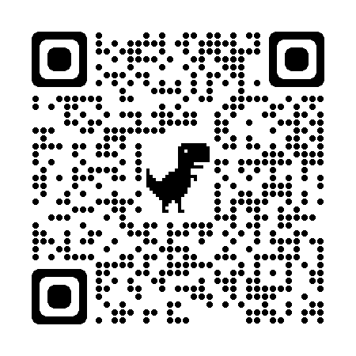

References available upon request.

